
YEAR 10 SCIENCE
Name:
Class:

Mark: /10

%

ARC TRANSITION
ASSESSMENT SIX
THE SCIENCE OF AIRBAGS


PART ONE: Air Bag Study Guide
Research airbags and complete the following questions.

1. What is the intended purpose of an air bag?

2. What is a major concern with air bags?

3. What is being done to make air bags safer?

4. What are three rules for drivers of cars with passenger-side air
bags?
1.
2.
3.
5. What gas fills up the air bag?

6. Explain how an air bag works.

7. How long does it take for the air bag to inflate?

PART TWO: It's a Crash Test, Dummy
The engineers who design air bags are able to determine the exact quantity of chemicals needed to inflate the air bag to the proper volume, and in the correct amount of time. If the air bag is under inflated or inflates too quickly, the passenger will still be injured by the steering wheel. If the air bag over inflates or inflates too slowly, the passenger will hit the inflating airbag and be injured. It is critical to get just the right amount of gas in the air bag.
During this exploration, you will attempt to find the amount of sodium bicarbonate (baking soda) required to react with 25 ml of acetic acid (vinegar) so that the bag is inflated, with no appreciable quantity of either reactant left. This will allow you to develop some idea of a limiting reactant. (Depending on the atmospheric pressure, the amount of baking soda required to fully inflate the bag should be between 1.5 and 3.0 grams.)

In this reaction, acetic acid combines with sodium bicarbonate to form water, carbon dioxide, and sodium acetate. The chemical equation for this reaction is:
HC₂H₃O₂ + NaHCO₃ ---> H₂O + CO₂ + NaC₂H₃O₂
The carbon dioxide is the gas that fills the bag, and the sodium acetate will be dissolved in the water. It is important to realize that this is not exactly how an air bag works, but is a good analogy that allows you to simulate the inflation of a protective device in the classroom.
Be prepared for some messes with the egg drop test. It is recommended that a plastic sheet be placed under the "drop zone" to assist in cleaning up. It is important to find a container for the egg drop that is the right size; three-pound butter tubs or small shoe boxes work well. Also be sure to wash your hands well after handling raw eggs.

It’s a Crash Test, Dummy
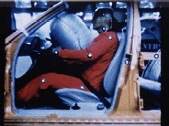

Introduction
In a real automobile safety restraint system, the air bag is a large plastic bag of about 65.0 L which fills with nitrogen as soon as a sensor tells it that the car’s forward momentum has been drastically lowered. The nitrogen is produced by the rapid decomposition of sodium azide (NaN3), which produces nitrogen gas (N2).
In this lab, we will create our own air bag technology utilizing sodium bicarbonate (baking soda) and acetic acid (vinegar). Your task is to find the correct amounts of sodium bicarbonate and acetic acid to use to create the right amount of gas (carbon dioxide) to fill the bag. If done correctly, your bag should fill up, but not pop open. There also should not be any sodium bicarbonate or acetic acid left in the bag.

Part 1
Procedure:
Before starting, look at the data table in which you will record the amount of acid, the amount of sodium bicarbonate, a description of how the bag inflated, and whether there was acetic acid or sodium bicarbonate left over.
1. To keep it simple, you are always going to have the same amount of acetic acid in the bag: 25 ml. Add 25 ml of acid to the bag.
2. Then measure 0.5 grams of sodium bicarbonate and record it in the data table. Place the sodium bicarbonate in a small piece of tissue.
3. Drop the sodium bicarbonate wrapped in tissue into the bag. Flatten the bag to remove the air and seal the bag as quickly as possible. As soon as the acetic acid soaks through the tissue, the chemicals will begin to react and bubble; the gas that is produced is carbon dioxide (CO₂). The bag should begin to inflate.
4. When the bubbling stops, mix the ingredients around to be sure that the reaction is complete.
5. Then test how inflated the bag is by pinching it. Write a description in the data table.
6. If all of the sodium bicarbonate seems to be gone, open the bag and add a small amount of sodium bicarbonate to see if more bubbles form. If they do, then there was still some acetic acid left in the bag. If not, then all of the acetic acid reacted. Make a note in the data table if there was acetic acid left in the bag.
7. Repeat this process by increasing the amount of sodium bicarbonate by 0.5 grams until all of the acetic acid is used up, indicated by the presence of sodium bicarbonate in the bag (because there was no acetic acid left to react with it).

DATA TABLE
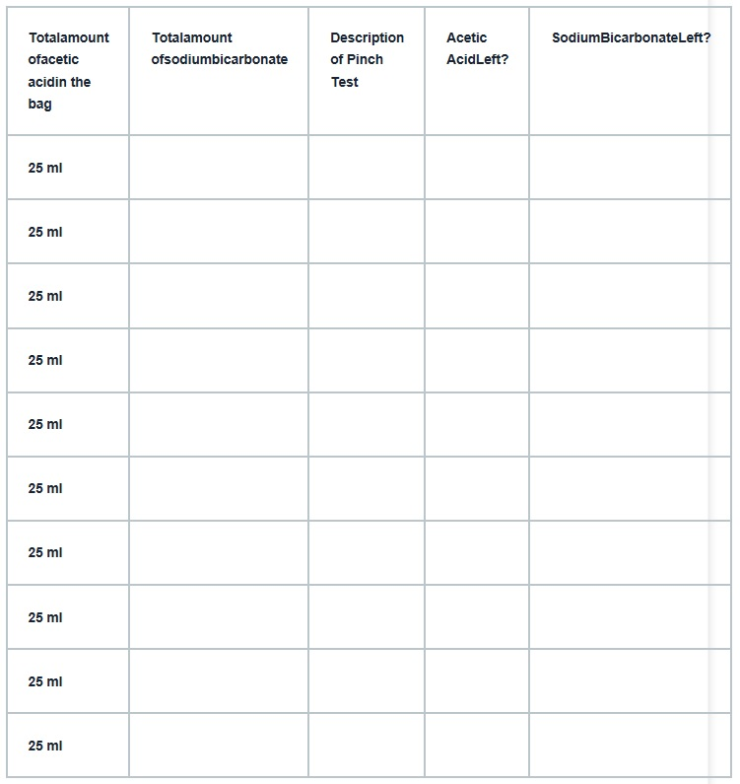

Part 2
Now you will put this knowledge to the test: a crash test. You will design and build a “vehicle” for your crash test dummy, a raw egg. The goal here is to build your vehicle so that it will protect the egg from breaking, even when dropped from a height of 2 meters.
The only materials you can use are:
- a container for the egg (e.g., a small cardboard box or large butter tub)
- two plastic bags
- acetic acid
- sodium bicarbonate
- tape
- a graduated cylinder
- a balance
- a meter stick
Procedure:
Follow the steps below using the ratio of sodium bicarbonate to acetic acid that inflated the bag, with no acetic acid or sodium bicarbonate left over. (You wouldn’t want acid in your air bag, would you?)
1. Inflate one or both bags, whichever you think would work best.
2. Place the inflated bag(s) and the egg in the container.
3. Drop from 2 meters.
4. Check your passenger. Did it survive the crash?
Analysis and Conclusions:
1. How much sodium bicarbonate had been added when there appeared to be no acetic acid or sodium bicarbonate left after the reaction?

2. Did this amount of sodium bicarbonate (when there was no acetic acid or sodium bicarbonate left) inflate the bag fully? If not, how could you change the amounts of sodium bicarbonate and acetic acid so that the bag is full, but with no reactants left over?

3. What are reactants? Use question #2 to help you form a definition for “reactants.”

4. Draw a picture of the vehicle you used.

5. What was the result of your crash test?

6. What changes would you make to your vehicle to further protect your passenger?

7. How is this experiment similar to an air bag in a car? How is it different?

8. How does figuring out the correct ratio of reactants help manufacturers of real air bags.

